EXPERIMENT 5: Bias–Variance, Overfitting and Underfitting Analysis

1. Aim
To fit polynomial regression models of degrees 1, 3, 9 and 15 to 150 noisy real-estate samples, visualize underfitting, good fit and overfitting, compare training and validation errors, and estimate bias² and variance using repeated resampling with Scikit-learn, NumPy and Matplotlib.
2. Formulas
1. Polynomial regression: ŷ = β₀ + β₁x + β₂x² + … + βₙxⁿ
2. Mean Squared Error (MSE): MSE = (1/N) Σ(yᵢ − ŷᵢ)²
3. Bias²: Bias² = (E[ŷ(x)] − f(x))²
4.Variance: Var(ŷ(x)) = E[(ŷ(x) − E[ŷ(x)])²]
5. Bias–variance decomposition (conceptual): Expected prediction error ≈ Bias² + Variance + Irreducible noise
3. Overall Flow Diagram
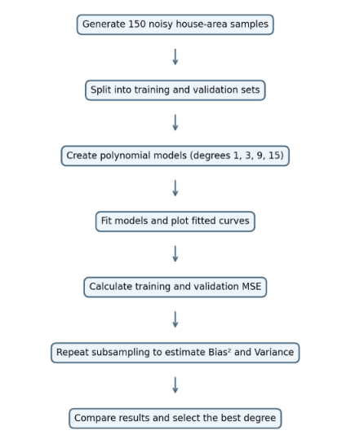

4. Code :

import numpy as np
import matplotlib.pyplot as plt

from sklearn.model_selection import train_test_split
from sklearn.preprocessing import PolynomialFeatures, MinMaxScaler, StandardScaler
from sklearn.linear_model import LinearRegression
from sklearn.pipeline import Pipeline
from sklearn.metrics import mean_squared_error

rng = np.random.default_rng(42)

X = rng.uniform(500, 2500, 150).reshape(-1, 1)

def true_price(area):
z = (np.asarray(area) - 500) / 2000
return 100 + 180*z + 260*z**2 + 35*np.sin(2*np.pi*z)

y = true_price(X.ravel()) + rng.normal(0, 25, 150)

X_train, X_val, y_train, y_val = train_test_split(
X, y, test_size=0.25, random_state=42
)

degrees = [1, 3, 9, 15]

def make_model(degree):
return Pipeline([
("input_scaling", MinMaxScaler()),
("poly", PolynomialFeatures(
degree=degree, include_bias=False
)),
("feature_scaling", StandardScaler()),
("regression", LinearRegression())
])

models = {}
train_errors = []
val_errors = []

for degree in degrees:

model = make_model(degree)
model.fit(X_train, y_train)

models[degree] = model

train_pred = model.predict(X_train)
val_pred = model.predict(X_val)

train_errors.append(
mean_squared_error(y_train, train_pred)
)

val_errors.append(
mean_squared_error(y_val, val_pred)
)

print("Degree:", degree)
print("Training MSE:", round(train_errors[-1], 2))
print("Validation MSE:", round(val_errors[-1], 2))
print()

x_plot = np.linspace(500, 2500, 400).reshape(-1, 1)

plt.figure(figsize=(10, 6))

plt.scatter(X_train, y_train, label="Training Data")
plt.scatter(X_val, y_val, marker="x", label="Validation Data")

for degree, model in models.items():
plt.plot(
x_plot,
model.predict(x_plot),
label=f"Degree {degree}"
)

plt.xlabel("Floor Area (sq. ft.)")
plt.ylabel("House Price (Synthetic Units)")
plt.title("Polynomial Regression Fitting")
plt.legend()
plt.grid()
plt.show()

plt.figure(figsize=(8, 5))

plt.plot(degrees, train_errors, marker="o",
label="Training Error")

plt.plot(degrees, val_errors, marker="s",
label="Validation Error")

plt.xlabel("Polynomial Degree")
plt.ylabel("Mean Squared Error")
plt.title("Training and Validation Error vs Model Complexity")
plt.xticks(degrees)
plt.legend()
plt.grid()
plt.show()

grid = np.linspace(500, 2500, 100).reshape(-1, 1)
true_values = true_price(grid.ravel())

rng_bv = np.random.default_rng(123)

bias_values = []
variance_values = []

for degree in degrees:

predictions = []

for _ in range(100):

indices = rng_bv.choice(
len(X_train),
size=int(0.8 * len(X_train)),
replace=False
)
model = make_model(degree)
model.fit(
X_train[indices],
y_train[indices]
)
predictions.append(model.predict(grid))
predictions = np.asarray(predictions)
mean_prediction = predictions.mean(axis=0)
bias_squared = np.mean(
(mean_prediction - true_values)**2
)
variance = np.mean(
np.var(predictions, axis=0)
)
bias_values.append(bias_squared)
variance_values.append(variance)

print("Degree:", degree)
print("Bias Squared:", round(bias_squared, 2))
print("Variance:", round(variance, 2))
print()

plt.figure(figsize=(8, 5))
plt.plot(degrees, bias_values, marker="o",
label="Bias Squared")
plt.plot(degrees, variance_values, marker="s",
label="Variance")
plt.xlabel("Polynomial Degree")
plt.ylabel("Estimated Error")
plt.title("Bias-Variance Analysis")
plt.xticks(degrees)
plt.legend()
plt.grid()
plt.show()
5. Output
Degree: 1
Training MSE: 1090.69
Validation MSE: 991.05
Degree: 3
Training MSE: 609.92
Validation MSE: 658.9
Degree: 9
Training MSE: 566.24
Validation MSE: 687.88
Degree: 15
Training MSE: 547.68
Validation MSE: 673.1

Graph

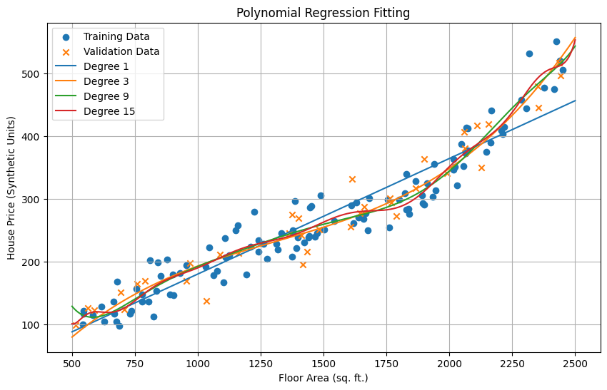
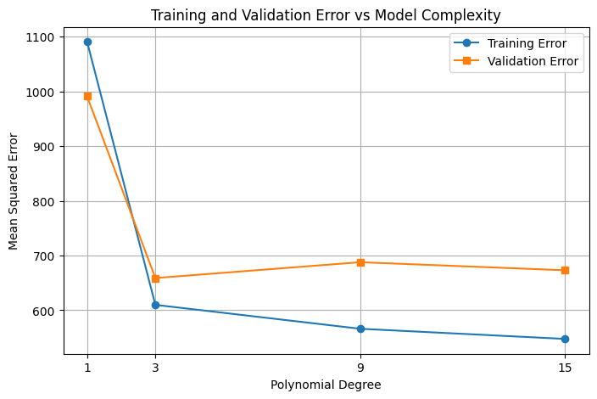
Degree: 1
Bias Squared: 669.84
Variance: 8.0
Degree: 3
Bias Squared: 34.74
Variance: 8.76
Degree: 9
Bias Squared: 52.38
Variance: 59.83
Degree: 15
Bias Squared: 675.9
Variance: 6317.27
Graph:
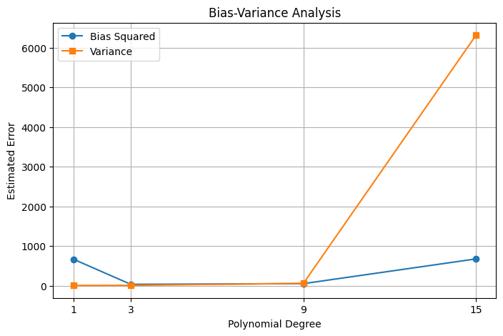

6. Result
Polynomial regression models of degrees 1, 3, 9 and 15 were successfully fitted to the 150 noisy real-estate samples using Scikit-learn. The fitted curves and error plots demonstrated underfitting at degree 1 and increasing overfitting at higher degrees. Repeated subsampling was used to estimate bias² and variance. Degree 3 was selected as the best model because it produced the lowest validation MSE (658.90) and a substantially better bias–variance balance than the higher-degree models.

